Part 1:



Conv layer 1 + ReLu

Conv layer 2 + ReLu

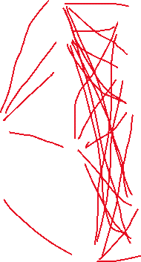

Max pool 2x2

7\*7\*64 = 3136 (flattened)

Input



Max pool 2x2

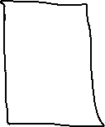

1024 fc neurons

7x7x64

14x14x64



10 outputs (with dropout)

28x28x32

28x28x1

Test accuracy: .9895 on step 4900

On step 0, the testing accuracy was at .1073, then it shot up to .9456 by step 100. The testing accuracies stayed between the ranges .98 and .99 throughout the rest of the steps. Overall, this CNN model generalized extremely well with unseen data and was able to properly classify the images about 98-99% of the time.

Part 2:



Conv layer 1 + ReLu



Max pool 2x2

14\*14\*64= 12544(flatten)

Input



1024 fc neurons



28x28x32

10 outputs (with dropout)

28x28x1

Test accuracy: .9877 on step 4900

On step 0, the testing accuracy was at .1089, then it shot up to .8882 by step 100. It took 600 more steps to reach the .98 mark in comparison to the two-convolution layer cnn, and unfortunately, the model was unable to hit a test accuracy of 99% in either of the steps. Overall this CNN model generalized well with unseen data, however, it was the inferior model in comparison to the two convolution layer CNN.

Part 3:

Test accuracy: .9849 on step 2900

On step 0, it obtained a test accuracy score of .1503, this was the highest starting score amongst the rest of the models. By step 100, it shot up to .8985, which was better than the one convolution layer, 5000 step cnn but not the two-convolution layer cnn. Just like the 5000 step one-convolution layer cnn, it was not able to reach a score of .99 in any of the steps. Overall, this CNN model generalized well with unseen data, and since this model and the one convolution layer, 5000 step cnn model had similar scores, this model was the superior model. This is because this model was able to reach similar levels of accuracy in less steps which makes it less computationally expensive.

The two-convolution layer CNN model was the highest performing model, so I would suggest this model if you wanted the model to be very accurate, If you want a model that is not computational expensive and a little bit less accurate, I would suggest using the one layer convolution cnn with 3000 steps.